./

GENESIS - Learning Outcome & Mini-project Summary Report



|  |  |  |  |  |  |
| --- | --- | --- | --- | --- | --- |
| **Ver. Rel. No.** | **Release Date** | **Prepared. By** | **Reviewed By** | **To be Approved** | **Remarks/Revision Details** |
| 1 | 12/12/2020 | Naga Teja |  |  |  |
|  |  |  |  |  |  |
|  |  |  |  |  |  |
|  |  |  |  |  |  |
|  |  |  |  |  |  |

**Details**

1. Simple calculator

Create a simple calculator which can perform basic arithmetic operations like addition, subtraction, multiplication or division depending upon the user input.

**Approach:**

User choose the desired operation. Options 1, 2, 3 and 4 are valid.

Two numbers are taken and an if…elif…else branching is used to execute a particular section.

Using functions add (), subtract (), multiply () and divide () evaluate respective operations.

def add(x, y):

return x + y

def subtract(x, y):

return x - y

def multiply(x, y):

return x * y

def divide(x, y):

return x / y

def addComplex(z1, z2):

return z1 + z2

def subComplex(z1, z2):

return z1 - z2

print("Select operation.")

print("1.Add")

print("2.Subtract")

print("3.Multiply")

print("4.Divide")

print("5.Add")

print("6.sub")

while True:

# Take input from the user

choice = input("Enter choice(1/2/3/4/5/6): ")

# Check if choice is one of the four options

if choice in ('1', '2', '3', '4', '5', '6'):

if choice == '1':

num1 = float(input("Enter first number: "))

num2 = float(input("Enter second number: "))

print(num1, "+", num2, "=", add(num1, num2))

elif choice == '2':

num1 = float(input("Enter first number: "))

num2 = float(input("Enter second number: "))

print(num1, "-", num2, "=", subtract(num1, num2))

elif choice == '3':

num1 = float(input("Enter first number: "))

num2 = float(input("Enter second number: "))

print(num1, "*", num2, "=", multiply(num1, num2))

elif choice == '4':

num1 = float(input("Enter first number: "))

num2 = float(input("Enter second number: "))

print(num1, "/", num2, "=", divide(num1, num2))

elif choice == '5':

z1 = complex(input('Enter first complex number: '))

z2 = complex(input('Enter first complex number: '))

print("Addtion is : ", addComplex(z1, z2))

elif choice == '6':

z1 = complex(input('Enter first complex number: '))

z2 = complex(input('Enter first complex number: '))

print("Addtion is : ", subComplex(z1, z2))

break

else:

print("Invalid Input")

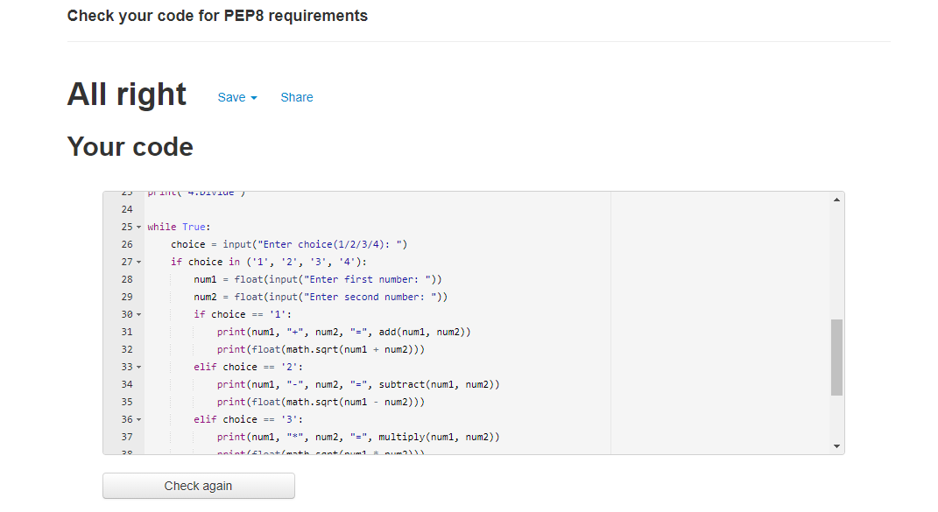

With oops:

import re

class First:

def __init__(self):

self.x = float(input("Enter first number:"))

self.y = float(input("Enter second number:"))

print(re.match("[a-z]+@[a-z]+\.[a-z]{1,3}", "nagateja@gmail.com"))

class second(First):

def add(self):

z = self.x + self.y

print("Sum is:", z)

class Third(First):

def sub(self):

z = self.x - self.y

print("sub is:", z)

class fourth(First):

def mul(self):

self.z = self.x * self.y

print("mul is:", self.z)

class five(First):

def div(self):

z = self.x / self.y

print("Division is:", round(z, 2))

class Naga:

def __init__(self):

print(re.match("[a-z]+@[a-z]+\.[a-z]{1,3}", "nagateja@gmail.com"))

self.c = self.six()

class six:

def __init__(self):

self.a = complex(input("Enter comp number:"))

self.b = complex(input("Enter comp number:"))

def add_Complex(self):

z = self. a + self. b

print("addComplex is:", z)

choice = 1

while choice != 0:

print("0. Exit")

print("1. Add")

print("2. Subtraction")

print("3. Multiplication")

print("4. Division")

print("5. addComplex")

choice = int(input("Enter choice: "))

if choice == 1:

obj = second()

obj.add()

elif choice == 2:

obj = Third()

obj.sub()

elif choice == 3:

obj = fourth()

obj.mul()

elif choice == 4:

obj = five()

obj.div()

elif choice == 5:

obj = Naga()

obj1 = obj.c

obj1.add_Complex()

elif choice == 0:

print("Exiting!")

else:

print("Invalid choice!!")

print()

